**Submitted by: Syed Arham Hussain**

**Repository Link:** <https://github.com/Arham24/Applied-Data-Science-Assignment-1>

**Assignment – 01: Visualization**

**Task - 01:**

In the first task, we are expected to create a line plot showing multiple lines along with the proper usage of title, legends, and labels.

As we know, a line plot is an effective technique for representing patterns over a duration or shifts in values across a spectrum. An instance of this could be depicting the variations in the average temperature throughout the year or the fluctuations in the stock price of a company over a period.

**Visualization of Weather in London:**

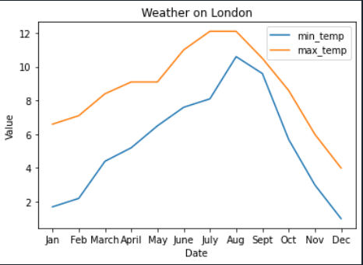

We can conclude with the help of insights that can be gained from this plot regarding the evolving trends, patterns, and connections among the variables. For example, it can reveal whether there are any seasonal patterns, divergences, or correlations between the variables, or notable changes in the values over time.

**Task – 02:**

We have chosen bar plot and pie chart to complete this task. The idea behind using bar graphs is because bar graphs are employed to contrast entities between distinct groups or categories to monitor shifts over time. Bar charts are more effective for measuring changes over time when the shifts are substantial in nature.

**Type – 01 Visual:**

**Visualization of Number of Students in Each Segment (Both Genders):**

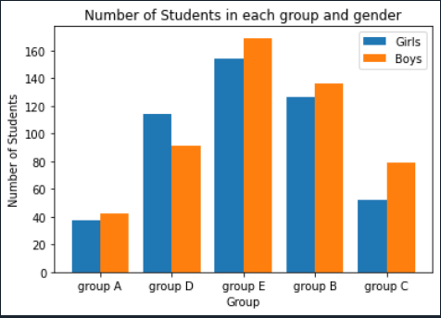

As we can see from this plot, that how the values are distributed across categories such as gender in different groups over the number of students present in each group. Thus, using Bar chart, we can see a concrete allocation between both genders.

**Type – 02 Visual:**

**Visualization of Number of Students % in Both Genders in Each Group:**

For the next plot, we have chosen pie chart, which gives a versatile graphical representation of statistical data that shows numerical proportions through a circular structure which is divided into several segments, and it is often used to depict financial, demographic, or statistical data in a visually striking and straightforward way.

They are best fitting with the use-case we have attempted to share that how many students are each group which is categorized into two genders. Thus, this graph helps us in determining the number of students (both male and female) in each of the categories that illustrates how all parts constitute a whole.